Monte Sano Elementary School

**2164 Richmond Avenue                                                                    Office: (706) 481-1813**

**Augusta, Georgia 30904                                                                      Fax: (706) 481-1814**

**Josephine Lane, Principal**

**Deantwa Bush-Corbitt, Administrative Intern**

Hello Monte Sano Hornet Families!!

Monte Sano Elementary is providing families the opportunity to retrieve any personal belongings students have remaining inside of our building. During the week of May 26th, Monte Sano parents/students will be able to pick up personal items left on campus. For the safety of all, we are asking that all Parents/Students **remain** in their vehicle.

Staff members will only address issues directly related to the activities of the drive thru. Other questions or concerns should be emailed to your student’s teacher.  We appreciate your patience and understanding during these trying times.

For grades Pre-K- 5, staff members have placed all student belongings in bags, and they will be handed out in a car line. We also ask that you please return all library books at this time. Pick-up will occur on Tuesday May 26th, Wednesday May 27th, and Thursday May 28th.

Please adhere to the following schedule and select a day during the appropriate time to pick-up your child(ren)’s belongings. For parents with multiple children attending Monte Sano who would like to make one trip, please select the time for your oldest child and you will receive all of your children’s belongings at that time.

|  |  |  |
| --- | --- | --- |
| Date | Grade Levels | Times |
| Tuesday, May 26th | Pre-K, K, 1st and 2nd | 8:30 am – 11:00 am |
| Tuesday, May 26th | 3rd, 4th, and 5th | 12:00 pm – 2:30 pm |
| Wednesday, May 27th | Pre-K, K, 1st, and 2nd | 8:30 am – 11:00 am |
| Wednesday, May 27th | 3rd, 4th, and 5th | 12:00 pm – 2:30 pm |
| Thursday, May 28th | Make-up | 8:30 am – 12:30 pm |

For your safety and ours, it is imperative that you follow all instructions.

1. Follow the red arrows stopping at each of the 2 yellow zones.
2. Wait to be directed by staff members at each zone.
3. **Wait in your vehicle.**

Enter using the car rider entrance between the school and the church.

1. Zone 1 – Provide the designated teacher the name and current grade level of student(s). Ms. Wheeler will give you a cone number to park beside.
2. Zone 2 – Personnel – Will bring your student(s) personal belongings to your vehicle.

Exit at the back of the school on to Wrightsboro Road.

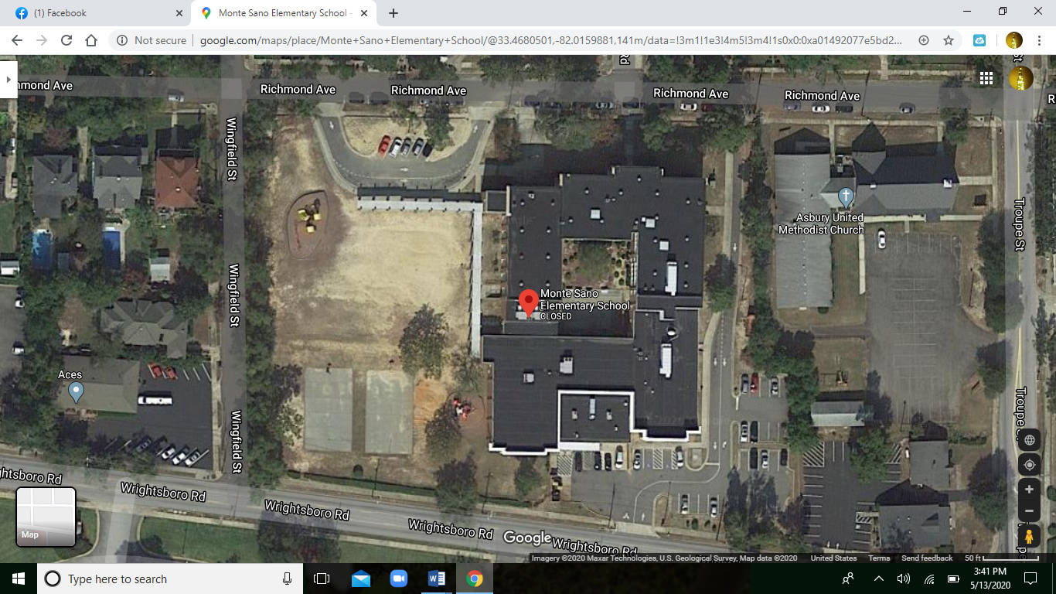

2

1

Please email your child(ren)’s teacher with any questions and/or concerns.

Sincerely,

Josephine Lane,

Principal